SUPERVISED LEARNERS

PSYCHOMETRIC EMOTION DETECTOR

ASHA SINGH-20CSU374

ANANYA SHARMA-20CSU303

ANANYA CHIBBER-20CSU205

SHIVRAJ-20CSU346

**ABSTRACT**

Computer vision has the challenge to detect the facial emotions of humans. Recently, in computer vision and machine learning, it’s possible to detect emotion from video or image accurate. In our research will propose to classify facial emotion using Haar-Cascade Classifier and Convolutional Neural Networks.

Recently online video interviews have been increasingly used in the employment process. The use of non-verbal cues such as gestures, body movements and facial expressions convey the feeling and feedback of the user. Though several automatic techniques have emerged to analyze the interview videos, so far, only simple emotion analyses have been attempted.

So, we have created Psychomo-D which helps in Emotion Detection using Haar-Cascade Classifier and Convolutional Neural Network (CNN) for the psychometric interviews.

**INTRODUCTION**

Emotion detection is the process of identifying human emotions.

Main components of emotion detection used in psychometric interviews:

Face detection diagram:

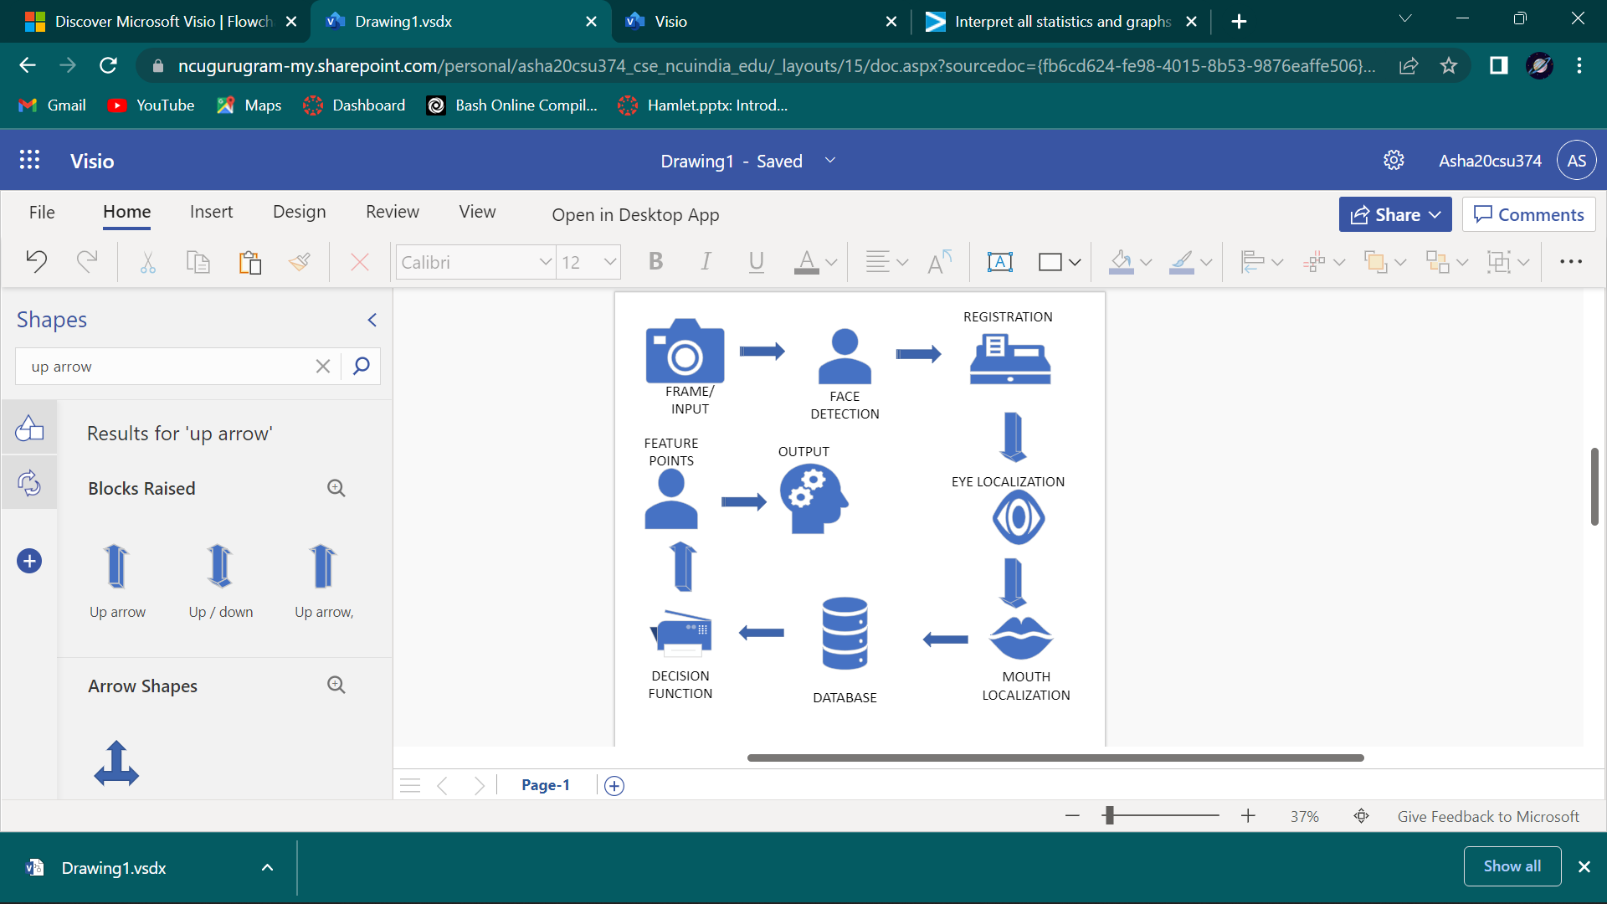

**Face Detection and Emotion Recognition using Geometric Feature based Process**

**Image standardization**: it includes various sub-processes such as the removal of noise from the image, making all the images uniform in size and conversation from Red, Green and Blue (RGB) to grayscale.

**Face detection**: It aims to remove all the unwanted things from the picture, such as background and to keep relevant information, the face from the data.

**Facial component analysis**: Here, regions of interests are detected. This step is necessary as it helps to minimize the errors that can arise due to rotation or the alignment of the face.

**FUNCTIONING OF THE DATA**

**DATA PREPROCESSING:**

Before using the data, it is important to go through a series called pre-processing. This makes the data easier to handle.

The data is stored in a csv file. Each row in csv file denotes an instance.

Every instance has two column attributes:

* Pixels of the image stored in string format.
* Integer encoding of the target label.

There is a total of 20,000 images distributed equally across the five emotions.

The images are 48X48 grayscale cropped images. The csv file consists of a flattened array of image stored in the form of a string.

The target labels are integer encoded in the csv file. They are mapped as follows:

0 🡪 Angry

1 🡪 Happy

2 🡪 Sad

3 🡪 Surprise

4 🡪 Neutral

Load the dataset:

This data contains the raw pixel values of the images.

Splits the data:

1. Training set: the algorithm will read or train on this over and over again to try and learn its task.
2. Testing set: the algorithm is tested on this data to see how it works.

**SENTIMENT ANALYSIS:**

The analysis of human sentiments like anger, sadness etc which is also referred to as mining of opinions or emotions AI in circumstances, is the study of different states of the human brain. Factors that are responsible for making sentiment analysis possible are natural language processing, computational linguistics, text mining and analysis of biometrics.

**CONSTRAINTS:**

* Psychomo-D only works and can detect only 5 emotions- anger, happy, sad, surprise and neutral.
* Although it works for all the profiles of the face, but it is important that the face must be visible to the detector clearly.
* It works for the faces at a distance of approximately 15 cm from the screen because that is the distance when you can actually see the face clearly.
* There are limitations with different types and versions of the software such as dataset input is only image and video. Audio inputs, patterns, textual data are invalid.

**CONCLUSION**

Emotion sensing technologies are evolving at this stage. Once it matures, advantages of Emotion Sensing Technology will help mankind in various aspects of life. The most beneficial is that it will avoid accidents or tragedies resulting due to driver's state of mind, drowsiness, irritation etc. It will take time to overcome drawbacks or disadvantages of Emotion Sensing Technology before it matures.